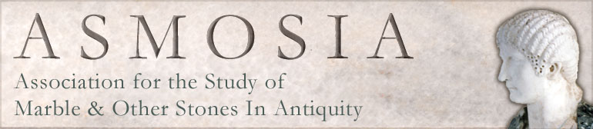GRANTS TO ATTEND THE ASMOSIA XIV CONFERENCE AT LJUBLJANA

ASMOSIA will offer three grants of 700 € each, for young researchers to facilitate their participation in the 14th ASMOSIA Conference at Ljubljana, 15-19 September 2025.

The grants are addressed to the following young researchers:

1. Post-graduate students of any degree.
2. Post-doctoral fellows in Universities or Research Institutes, having received their Doctoral degree no longer than 5 years before the date of the conference.
3. Young researchers, with or without a contract at a university or Research Institute and up to the age of 35 years.
4. All applicants should have an accepted abstract at the conference (oral or poster) and should be the first author of the paper.
5. They should not have their full expenses to attend the conference paid by other sources (University, Institute or other funding organization).

All those eligible should fill the following application form and send it to the ASMOSIA President [y.maniatis@inn.demokritos.gr](mailto:y.maniatis@inn.demokritos.gr)

APPLICATION FORM FOR GRANTS

Name/Surname:

Date of Birth:

Place of Birth/Nationality:

Affiliation if connected to University or Institute:

Home address:

Education:

Status/Position (student, stage, fellow, researcher, etc.). Give details of your status and research activities confirmed by official documentation from the Institution:

Title of accepted paper:

Reasons for requesting the Grant:

Provide information if you have funds from other sources for attending the conference and at what level (official confirmation will be required by University or Institute):

*Please send the completed form and accompanying documents to* [*y.maniatis@inn.demokritos.gr*](mailto:y.maniatis@inn.demokritos.gr)